**BUG_ID:** ONESIAM_001

**Title:** Cannot swipe the screen from left to right to close the screen.

**Step to reproduce:**

1. Go to ONESIAM application
2. Click on ลักชัวรี แชท & ช็อป
3. Slide from left to right

**Actual Behavior:** Unable to swipe (close) the screen, user needs to click on < icon.

**Expected Behavior:** User should be able to swipe to close the page e.g. Voucher menu.

**Device:** iPhone 14 Pro iOS 17.5.1

**Severity:** Minor

**Priority:** Low

**Screen Record/ ScreenShot:** Please see attachment “ONESIAM_001.mp4”

**BUG_ID:** ONESIAM_002

**Title:** Cannot edit product prices filter if product is not found on the first price filter.

**Step to reproduce:**

1. Go to ONESIAM application
2. Click on Shop
3. Select shop e.g. Loft
4. Click on See All in New In section
5. Click on filter icon
6. Add price range e.g. 3,000 - 3,900

**Actual Behavior:** When user encouter to the “Product is not found” screen. User cannot click on filter icon to edit price. User need to go back to the previous page to re-do the filter flow.

**Expected Behavior:** User should be able to click on filter icon and re-do filter flow.

**Device:** iPhone 14 Pro iOS 17.5.1

**Severity:** Minor

**Priority:** Medium

**Screen Record/ ScreenShot:** Please see attachment “ONESIAM_002.mp4”

**BUG_ID:** ONESIAM_003

**Title:** Error message appears when user adds price out of the range.

**Step to reproduce:**

1. Go to ONESIAM application
2. Click on Shop
3. Select shop e.g. Loft
4. Click on See All in “New In” section
5. Click on the filter icon
6. Add price out of range

**Actual Behavior:** Error message is appearing

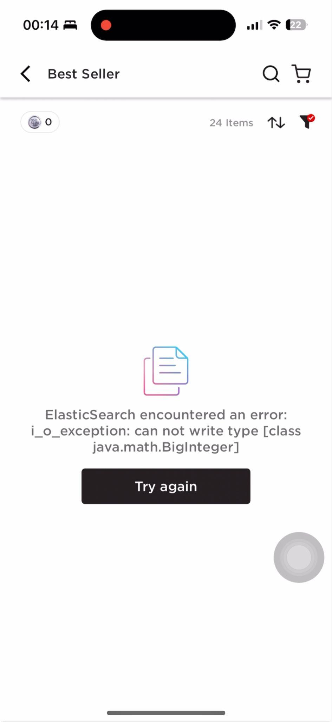

**Expected Behavior:** There should be a fill limitation for price filter.

**Device:** iPhone 14 Pro iOS 17.5.1

**Severity:** Low

**Priority:** Low

**Screen Record/ ScreenShot:** Please see attachment “ONESIAM_003.mp4”

**BUG_ID:** ONESIAM_004

**Title:** My privilege result is incorrect when filter from A to Z.

**Step to reproduce:**

1. Go to ONESIAM application
2. Scroll to privilege section
3. Click on See All
4. Filter Voucher name from A to Z

**Actual Behavior:** Voucher displayed by start with “LOFT” followed by “Absolute Siam”, “Air Canada”, etc.

**Expected Behavior:** Voucher should start with the letter A.

**Device:** iPhone 14 Pro iOS 17.5.1

**Severity: Minor**

**Priority: Low**

**Screen Record/ ScreenShot:** Please see attachment “ONESIAM_004.mp4”

**BUG_ID:** ONESIAM_005

**Title:** User can submit invalid email to the system

**Step to reproduce:**

1. Go to ONESIAM application
2. Click on icon on the top left
3. Click on Account Details menu
4. Add invalid email tear@gmail.123
5. Enter

**Actual Behavior:** User can submit email successfully.

**Expected Behavior:** Error should be appear after user submit invalid email.

**Device:** iPhone 14 Pro iOS 17.5.1

**Severity:** Minor

**Priority:** Low

**Screen Record/ ScreenShot:** ONESIAM_005.PNG

